When YMCA is stronger than AARP: Village People stop in NJ as part of 40th anniversary tour
June 27, 2017
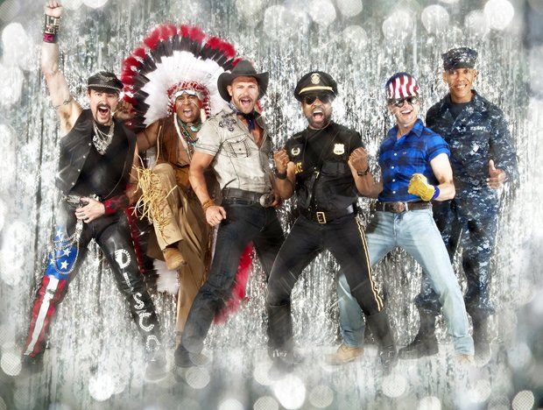
Disco legends Village People bring their energy and anthems to Bergen Performing Arts Center June 29 and Golden Nugget Atlantic City July 1.

By Natalie Pompilio
For NJ Advance Media

You may not know Ray Simpson’s name or face, but you'd recognize him if he walked into a room in his stage clothes. He's "The Cop" -- and lead singer -- of the Village People.
And he still fits into the tight pants and shiny shirt he first donned more than three decades ago.
"We do quite a bit of a show and it does keep you in shape," Simpson said in interview with NJ Advance Media. "We're dancing the whole time and the fans, it's the fans who have carried us over the last 30 or 40 years."
Simpson and his five bandmates -- a.k.a. "The Indian," "The Soldier." "The Construction Worker," "The Cowboy" and "The Biker" are the headliners of A Night at the Disco tour, which stops at the Bergen Performing Arts Center June 29 and the Golden Nugget Atlantic City July 1.
The Trammps -- whose song"Disco Inferno" enjoyed a resurgence during the 2016 presidential election as candidate Bernie Sanders playing the tune at rallies -- and Anita Ward -- singer of the much-sampled-to-this-day "Ring My Bell"-- share the bill.

While the songs may be older -- Village People's band's biggest hits, including "Macho Man," "YMCA" and "In the Navy," made the Billboard charts in the late '70s -- the band's audience is getting younger.
"You'll see three generations -- grandparents, parents, children," he said. "It's an all-ages audience.”
Another notable change from then to now: The song "YMCA" was originally denounced by the actual non-profit organization YMCA. This month, YMCA Australia released video of Boy George singing the song as a promotion.It begins with words across the screen, "For 40 years, this song has talked about us. Now we'd like to use it to talk to you."

"At this late date, we've finally become PG," he said. "Back in the day, we were late night, one o'clock in the morning. Now we're a matinee."
Simpson, who previously lived in Bergen County and fondly recalls buying costume accessories at Somes Uniforms in Hackensack, replaced original lead singer Victor Willis in 1980. Two members of the original line-up are still performing with the band-- Felipe Rose, "the Indian" and Alex Briley, "the Soldier."
"We still enjoy working. It's still a blast to entertain," Simpson said. "In this world, it's so important to life people's spirits and make them feel good about themselves and find out where they're at and what's going on."
There are no plans to add to the line-up any time soon, Simpson said, noting "Six of us on stage at the same time is enough."
But if the band was to expand? They could probably use a nurse or firefighter, "someone to keep everybody moving," he said.
With age comes wisdom. Those hips, those knees...

